| Experiment No.2 |
| --- |
| Command Line Arguments |
| Date of Performance: 19/07/24 |
| Date of Submission: 26/07/24 |

**Aim: -** Implementation of command line arguments to demonstrate how to pass and handle input directly from the command line.

**Objective: -** To use the facility of java to pass parameters to a program when it is executed.

**Theory**: - In java, there are three different ways for reading input from the user in the command line environment. The most preferred type of input is via the use of scanner class. The main purpose of the Scanner class is to parse primitive types and strings using regular expressions; however, it can also be used to read input from the user in the command line. Using scanner class, we can create an object to read input from the standard input channel "System.in".

Command-line arguments are values passed to a Java program when it's executed from the command line. These arguments can be used to provide input data, configure the program's behavior, or modify its output. The main method in a Java class accepts a String array named args as an argument. When you run the program with command-line arguments, they are stored as individual strings in this array. You can access these arguments using their index (starting from 0) within the args array.

**Code: -**

public class Math {

public static void main(String[] args) {

int a = Integer.parseInt(args[0]);

int b = Integer.parseInt(args[1]);

System.out.println("First number: " + a);

System.out.println("Second number: " + b);

System.out.println("ADDITION: " + (a + b));

System.out.println("SUBTRACTION: " + (a - b));

System.out.println("MULTIPLICATION: " + (a * b));

if (b != 0) {

System.out.println("DIVISION: " + (a / b));

} else {

System.out.println("DIVISION: Cannot divide by zero.");

}

}

}

**Output:-**

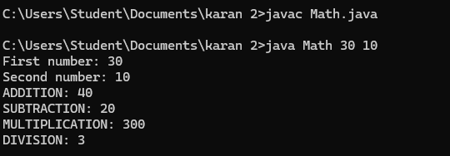

**Conclusion: -** Command-line arguments are parameters passed to a program at launch, whereas keyboard input is entered during program execution.

String args[] is an array that stores command-line arguments passed to the main method.